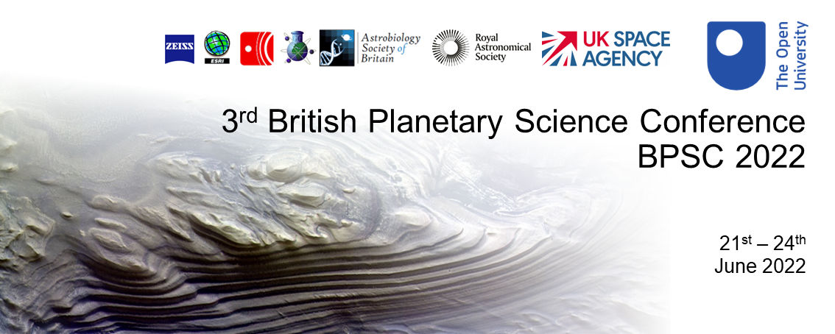
BPSC Travel Grant Award Application
Thanks to generous support from the UK Space Agency, the Royal Astronomical Society, and the Geochemistry Group of the Geological Society of London, the BPSC organising committee can offer a number of travel grants of up to £400 to cover accommodation and travel to BPSC 2022 in Milton Keynes, UK. We welcome applications from early career researchers. Full eligibility criteria are detailed in the appendix below.
To apply, please email bpsc2022@open.ac.uk (include “Travel Grant” in the subject header) by the 30th May, with the following three attachments:
- This completed form;
- A copy of the abstract to be presented;
- A short statement of support from the named research supervisor, project lead, or mentor. The letter of support must confirm the applicant’s current position (including year of study if relevant).
Applicants will be noted of the outcome of their application by the 3rd June at the latest.
Following the conference, successful applicants will be required to submit travel and accommodation receipts, as well as a short (< 500 word) report on their experience at the meeting and the impact the award had on the awardee before receiving reimbursement. Unfortunately, we are unable to provide this support in advance of the conference.
Personal Details
Name
Institution
Postal address
Phone #
Email
Position/Year of study
Source of funding
Research supervisor/lead/mentor

Financial Support
Expected total cost of travel | £
Expected total cost of accommodation | £
Other financial support available | £
Amount of support sought from the BPSC 2022 Travel Grant | £
Details of any applications to other funding bodies for the proposed conference

Justification (no more than 300 words) of the need for financial support (for example, will BPSC 2022 be your first in person scientific conference?)

In submitting this application, I confirm that the above details are correct and provide consent for BPSC 2022 to gather personal information in order to provide you with services relating to the Group. These data will be stored electronically for a period of not more than one year after the closing of the BPSC 2022 conference, and will only be used to contact the applicant regarding the BPSC 2022 Travel Grant.

Signed: Date:

Appendix: Eligibility criteria for the BPSC 2022 Travel Bursary
- Bursaries will only be awarded to researchers who have submitted an abstract to the BPSC 2022 conference.
- Bursaries are provided to cover, or contribute to, the cost of travelling to the meeting, and the cost of accommodation in Milton Keynes for the length of the conference (including workshop attendance).
- The sum awarded indicates the maximum value cost that the committee will fund and will typically be in the region of £300-£400.
- Only the actual cost of travel and accommodation will be reimbursed, even if this is less than the sum initially awarded.
- Recipients are required to submit a claim form for the expenses incurred (accompanied by receipts) along with a short (< 500 word) report on their experience at the meeting and the impact the award had on the awardee before receiving reimbursement.
- Preference will be given to researchers who are self or institutionally funded in the United Kingdom and Ireland.
- Preference will be given to postgraduate students in their second or third year of study.
- Preference will be given to researchers who have had limited experience of in person conference attendance as a direct result of the COVID-19 pandemic

